УО «Белорусский государственный университет информатики и радиоэлектроники»
Кафедра ПОИТ

Отчет по лабораторной работе №2
по предмету «Теория информации»
Вариант 17

Выполнил:
Астанов Т.Р.
Гр. 451004
Проверил:
Болтак С.В.

Минск 2026
Вариант № 17.

Реализовать систему потокового шифрования и дешифрования для файла с любым содержимым (с любым расширением) с помощью генератора ключевой последовательности на основе линейного сдвигового регистра с обратной связью LFSR(размерность регистра согласно выданному варианту). Начальное состояние регистра ввести с клавиатуры. Поле для ввода состояния регистра должно игнорировать любые символы кроме 0 и 1. Вывести на экран сгенерированный ключ (последовательность из 0 и 1), исходный файл и зашифрованный файл в двоичном виде. На диск сохранить зашифрованный/расшифрованный файл в виде потока байтов. Программа не должна быть написана в консольном режиме. Результат работы программы – зашифрованный/расшифрованный файл.
Степень многочлена – 39.
Примитивный многочлен: x^39 + x^4 + 1

Тестирование программного средства:

- Текстовый файл

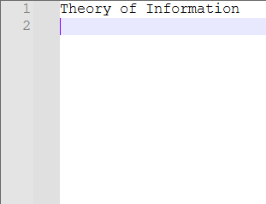

Пример работы программы:

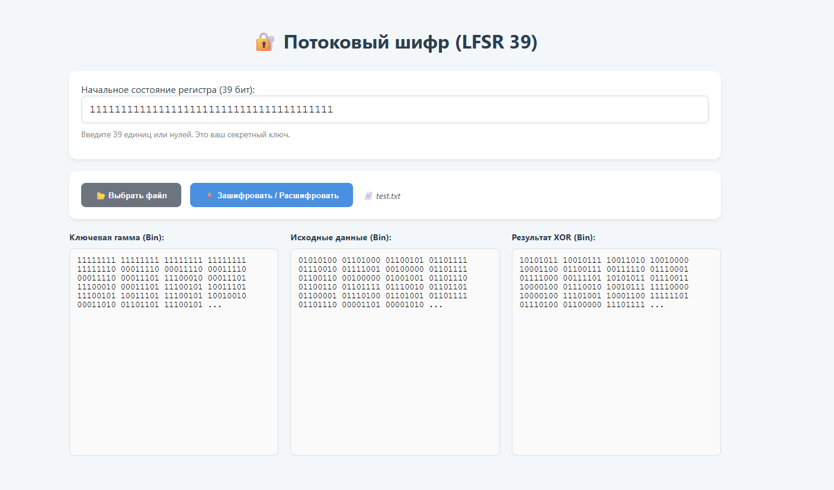

Зашифрованный файл:
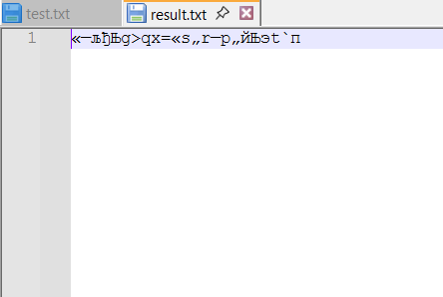

Дешифрованный файл:
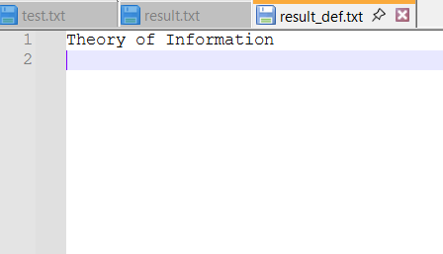

- Картинка в формате png

Пример работы программного средства:

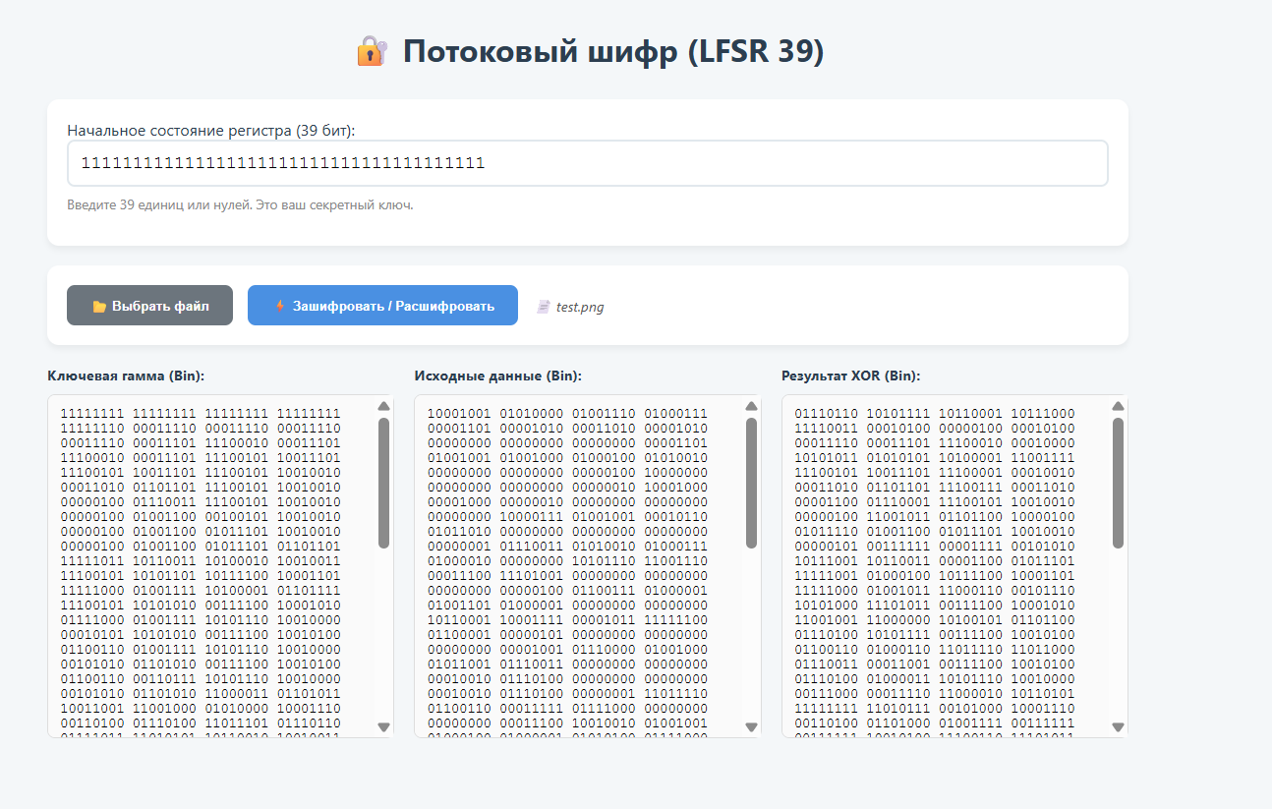

Зашифрованный файл:
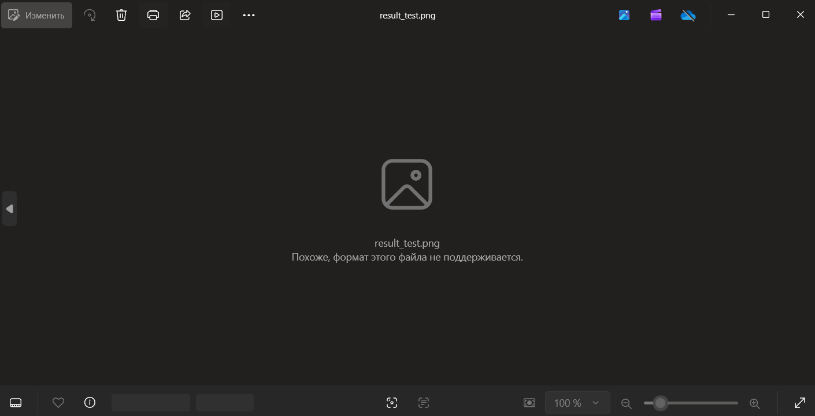

Дешифрованный файл:

- Работа со звуком
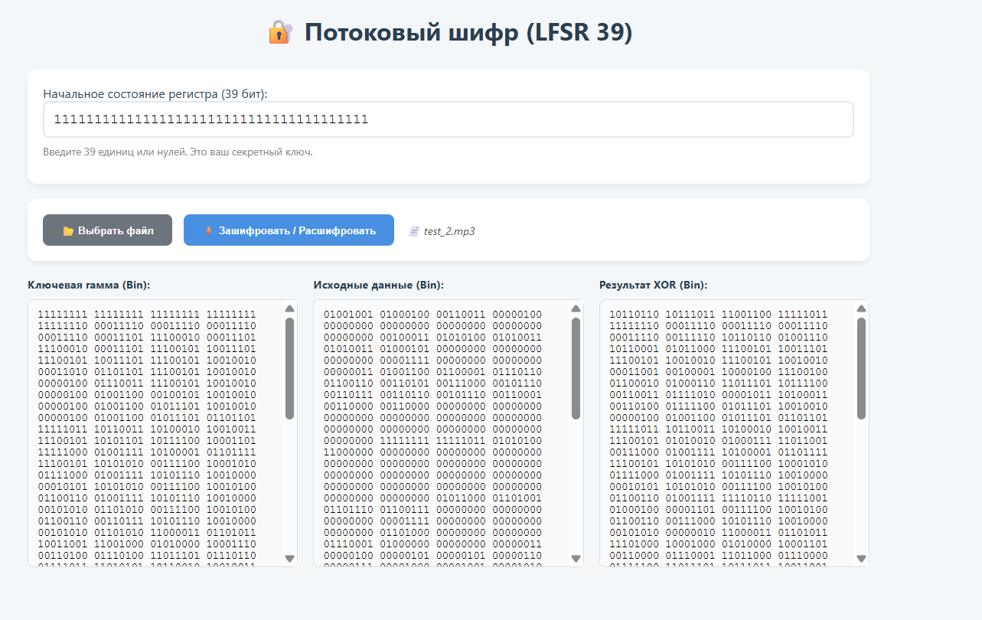

Зашифрованный файл:
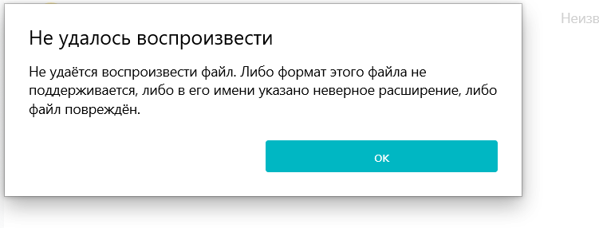
Дешифрованный файл:
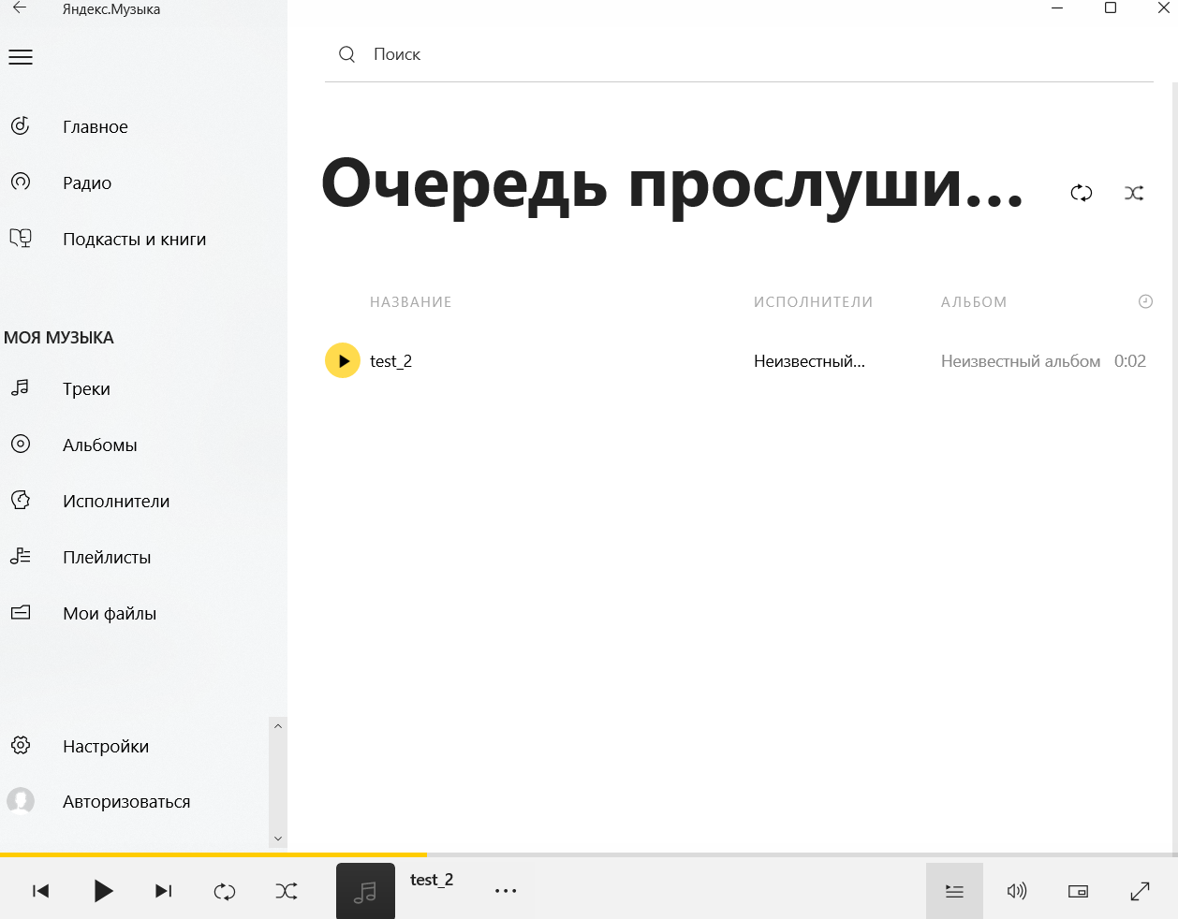

- Работа с pdf
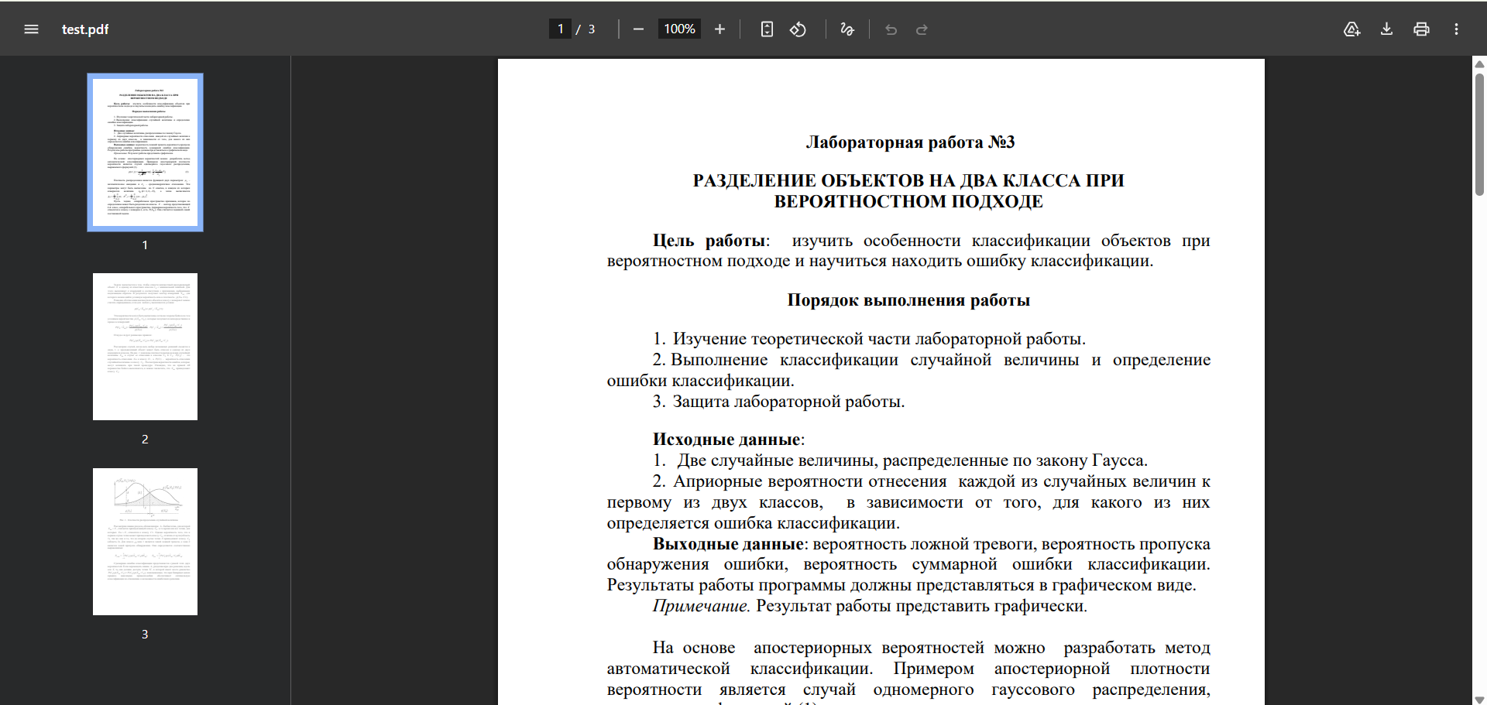

Пример работы программного средства:
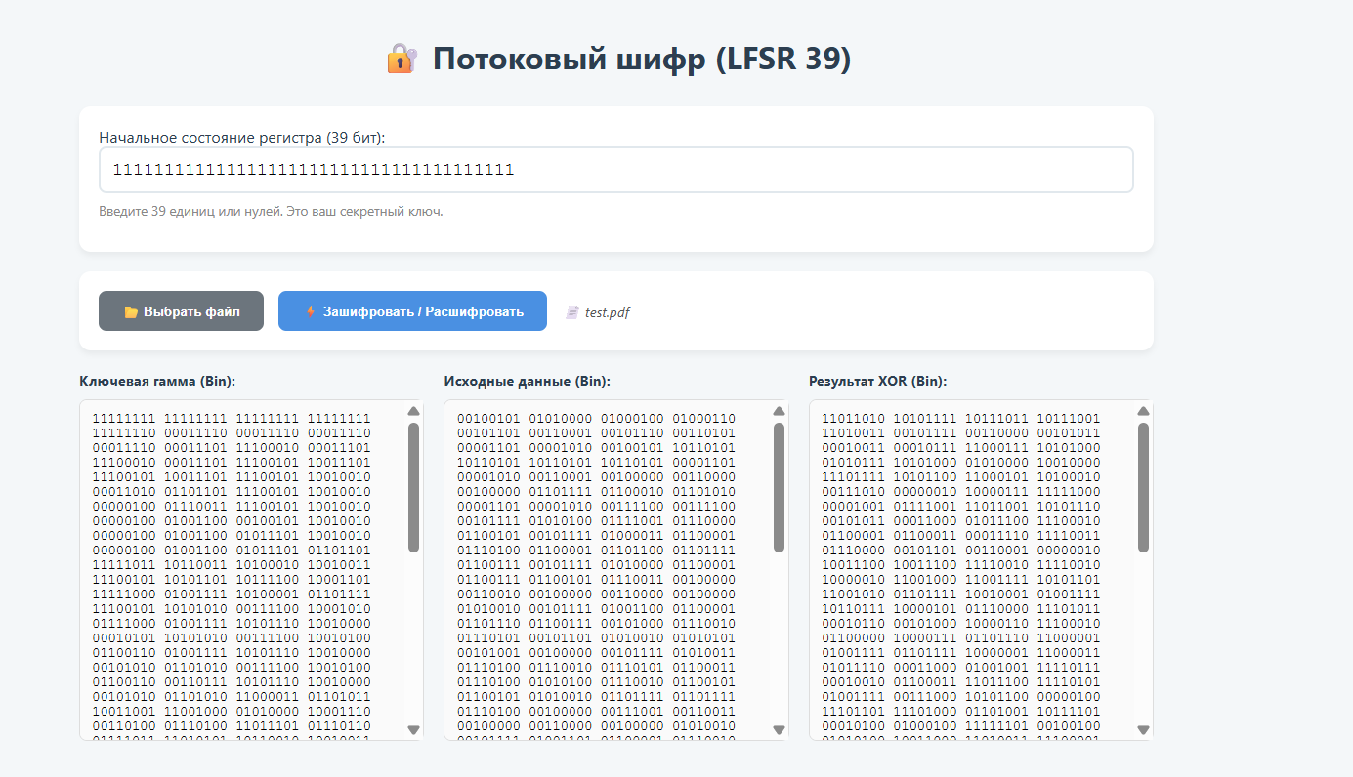

Зашифрованный файл:


Дешифрованный файл:
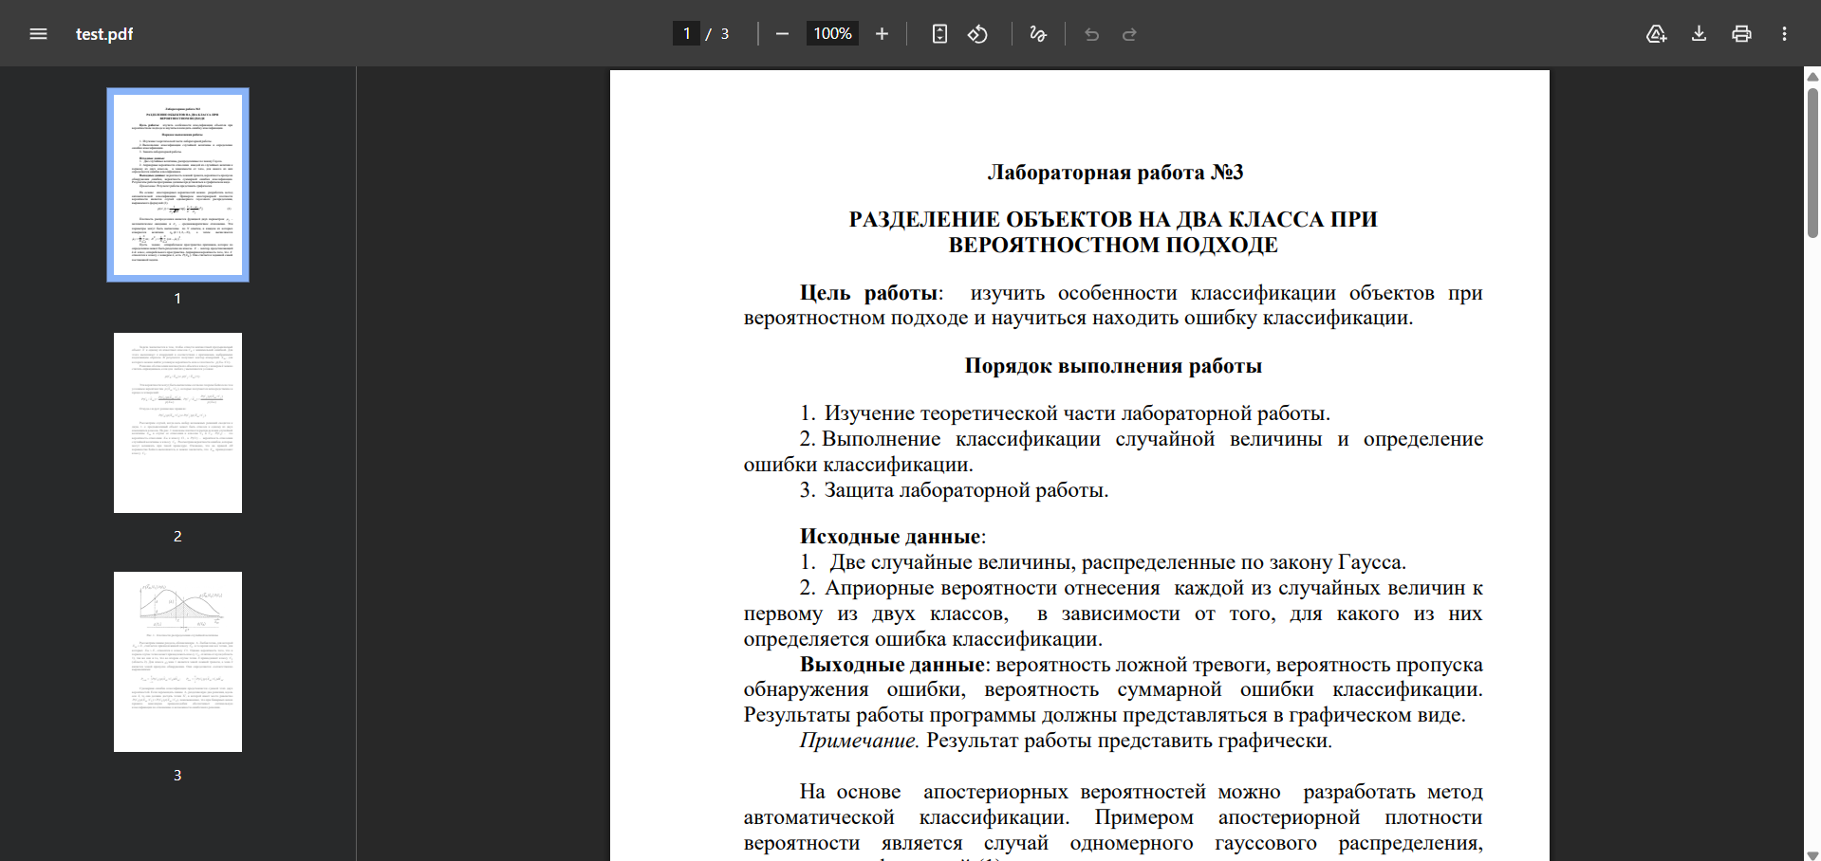
- Работа с видео:
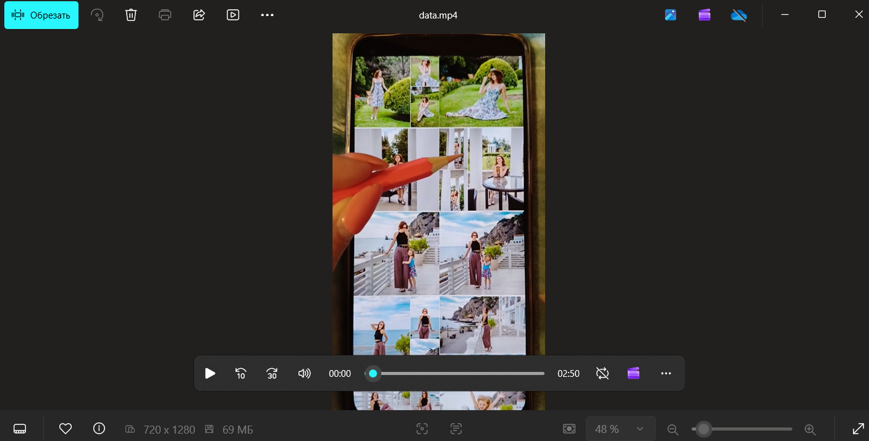

Пример работы программного средства:
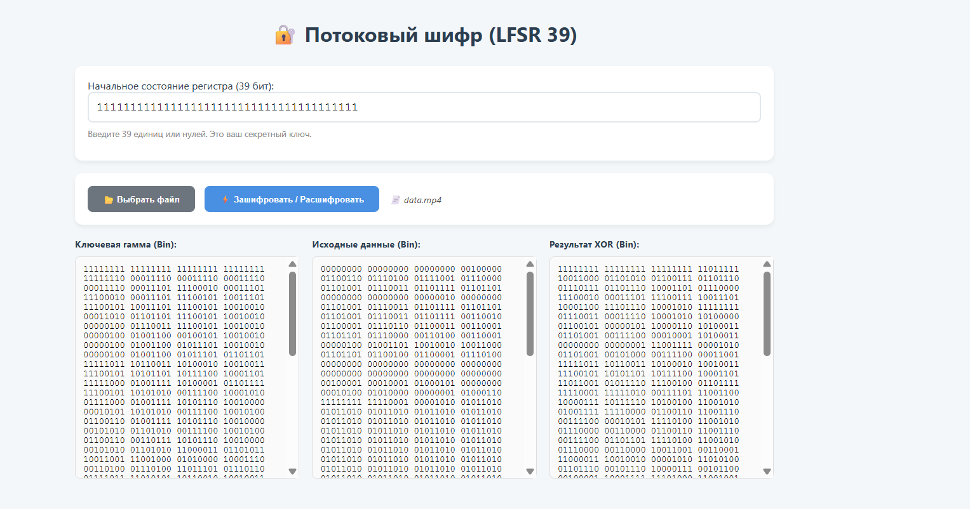

Зашифрованный файл:


Дешифрованный файл:


Пример работы LFSR:

 | 39 | 38 | 37 | 36 | 35 | 34 | 33 | 32 | 31 | 30 | 29 | 28 | 27 | 26 | 25 | 24 | 23 | 22 | 21 | 20 | 19 | 18 | 17 | 16 | 15 | 14 | 13 | 12 | 11 | 10 | 9 | 8 | 7 | 6 | 5 | 4 | 3 | 2 | 1 | xor
1 | 1 | 1 | 1 | 1 | 1 | 1 | 1 | 1 | 1 | 1 | 1 | 1 | 1 | 1 | 1 | 1 | 1 | 1 | 1 | 1 | 1 | 1 | 1 | 1 | 1 | 1 | 1 | 1 | 1 | 1 | 1 | 1 | 1 | 1 | 1 | 1 | 1 | 1 | 1 | 0
2 | 1 | 1 | 1 | 1 | 1 | 1 | 1 | 1 | 1 | 1 | 1 | 1 | 1 | 1 | 1 | 1 | 1 | 1 | 1 | 1 | 1 | 1 | 1 | 1 | 1 | 1 | 1 | 1 | 1 | 1 | 1 | 1 | 1 | 1 | 1 | 1 | 1 | 1 | 0 | 0
3 | 1 | 1 | 1 | 1 | 1 | 1 | 1 | 1 | 1 | 1 | 1 | 1 | 1 | 1 | 1 | 1 | 1 | 1 | 1 | 1 | 1 | 1 | 1 | 1 | 1 | 1 | 1 | 1 | 1 | 1 | 1 | 1 | 1 | 1 | 1 | 1 | 1 | 0 | 0 | 0
4 | 1 | 1 | 1 | 1 | 1 | 1 | 1 | 1 | 1 | 1 | 1 | 1 | 1 | 1 | 1 | 1 | 1 | 1 | 1 | 1 | 1 | 1 | 1 | 1 | 1 | 1 | 1 | 1 | 1 | 1 | 1 | 1 | 1 | 1 | 1 | 1 | 0 | 0 | 0 | 0
5 | 1 | 1 | 1 | 1 | 1 | 1 | 1 | 1 | 1 | 1 | 1 | 1 | 1 | 1 | 1 | 1 | 1 | 1 | 1 | 1 | 1 | 1 | 1 | 1 | 1 | 1 | 1 | 1 | 1 | 1 | 1 | 1 | 1 | 1 | 1 | 0 | 0 | 0 | 0 | 0
6 | 1 | 1 | 1 | 1 | 1 | 1 | 1 | 1 | 1 | 1 | 1 | 1 | 1 | 1 | 1 | 1 | 1 | 1 | 1 | 1 | 1 | 1 | 1 | 1 | 1 | 1 | 1 | 1 | 1 | 1 | 1 | 1 | 1 | 1 | 0 | 0 | 0 | 0 | 0 | 1
7 | 1 | 1 | 1 | 1 | 1 | 1 | 1 | 1 | 1 | 1 | 1 | 1 | 1 | 1 | 1 | 1 | 1 | 1 | 1 | 1 | 1 | 1 | 1 | 1 | 1 | 1 | 1 | 1 | 1 | 1 | 1 | 1 | 1 | 0 | 0 | 0 | 0 | 0 | 1 | 1
8 | 1 | 1 | 1 | 1 | 1 | 1 | 1 | 1 | 1 | 1 | 1 | 1 | 1 | 1 | 1 | 1 | 1 | 1 | 1 | 1 | 1 | 1 | 1 | 1 | 1 | 1 | 1 | 1 | 1 | 1 | 1 | 1 | 0 | 0 | 0 | 0 | 0 | 1 | 1 | 1
9 | 1 | 1 | 1 | 1 | 1 | 1 | 1 | 1 | 1 | 1 | 1 | 1 | 1 | 1 | 1 | 1 | 1 | 1 | 1 | 1 | 1 | 1 | 1 | 1 | 1 | 1 | 1 | 1 | 1 | 1 | 1 | 0 | 0 | 0 | 0 | 0 | 1 | 1 | 1 | 1
10 | 1 | 1 | 1 | 1 | 1 | 1 | 1 | 1 | 1 | 1 | 1 | 1 | 1 | 1 | 1 | 1 | 1 | 1 | 1 | 1 | 1 | 1 | 1 | 1 | 1 | 1 | 1 | 1 | 1 | 1 | 0 | 0 | 0 | 0 | 0 | 1 | 1 | 1 | 1 | 1
11 | 1 | 1 | 1 | 1 | 1 | 1 | 1 | 1 | 1 | 1 | 1 | 1 | 1 | 1 | 1 | 1 | 1 | 1 | 1 | 1 | 1 | 1 | 1 | 1 | 1 | 1 | 1 | 1 | 1 | 0 | 0 | 0 | 0 | 0 | 1 | 1 | 1 | 1 | 1 | 0
12 | 1 | 1 | 1 | 1 | 1 | 1 | 1 | 1 | 1 | 1 | 1 | 1 | 1 | 1 | 1 | 1 | 1 | 1 | 1 | 1 | 1 | 1 | 1 | 1 | 1 | 1 | 1 | 1 | 0 | 0 | 0 | 0 | 0 | 1 | 1 | 1 | 1 | 1 | 0 | 0
13 | 1 | 1 | 1 | 1 | 1 | 1 | 1 | 1 | 1 | 1 | 1 | 1 | 1 | 1 | 1 | 1 | 1 | 1 | 1 | 1 | 1 | 1 | 1 | 1 | 1 | 1 | 1 | 0 | 0 | 0 | 0 | 0 | 1 | 1 | 1 | 1 | 1 | 0 | 0 | 0
14 | 1 | 1 | 1 | 1 | 1 | 1 | 1 | 1 | 1 | 1 | 1 | 1 | 1 | 1 | 1 | 1 | 1 | 1 | 1 | 1 | 1 | 1 | 1 | 1 | 1 | 1 | 0 | 0 | 0 | 0 | 0 | 1 | 1 | 1 | 1 | 1 | 0 | 0 | 0 | 0
15 | 1 | 1 | 1 | 1 | 1 | 1 | 1 | 1 | 1 | 1 | 1 | 1 | 1 | 1 | 1 | 1 | 1 | 1 | 1 | 1 | 1 | 1 | 1 | 1 | 1 | 0 | 0 | 0 | 0 | 0 | 1 | 1 | 1 | 1 | 1 | 0 | 0 | 0 | 0 | 0
16 | 1 | 1 | 1 | 1 | 1 | 1 | 1 | 1 | 1 | 1 | 1 | 1 | 1 | 1 | 1 | 1 | 1 | 1 | 1 | 1 | 1 | 1 | 1 | 1 | 0 | 0 | 0 | 0 | 0 | 1 | 1 | 1 | 1 | 1 | 0 | 0 | 0 | 0 | 0 | 1
17 | 1 | 1 | 1 | 1 | 1 | 1 | 1 | 1 | 1 | 1 | 1 | 1 | 1 | 1 | 1 | 1 | 1 | 1 | 1 | 1 | 1 | 1 | 1 | 0 | 0 | 0 | 0 | 0 | 1 | 1 | 1 | 1 | 1 | 0 | 0 | 0 | 0 | 0 | 1 | 1
18 | 1 | 1 | 1 | 1 | 1 | 1 | 1 | 1 | 1 | 1 | 1 | 1 | 1 | 1 | 1 | 1 | 1 | 1 | 1 | 1 | 1 | 1 | 0 | 0 | 0 | 0 | 0 | 1 | 1 | 1 | 1 | 1 | 0 | 0 | 0 | 0 | 0 | 1 | 1 | 1
19 | 1 | 1 | 1 | 1 | 1 | 1 | 1 | 1 | 1 | 1 | 1 | 1 | 1 | 1 | 1 | 1 | 1 | 1 | 1 | 1 | 1 | 0 | 0 | 0 | 0 | 0 | 1 | 1 | 1 | 1 | 1 | 0 | 0 | 0 | 0 | 0 | 1 | 1 | 1 | 1
20 | 1 | 1 | 1 | 1 | 1 | 1 | 1 | 1 | 1 | 1 | 1 | 1 | 1 | 1 | 1 | 1 | 1 | 1 | 1 | 1 | 0 | 0 | 0 | 0 | 0 | 1 | 1 | 1 | 1 | 1 | 0 | 0 | 0 | 0 | 0 | 1 | 1 | 1 | 1 | 1
21 | 1 | 1 | 1 | 1 | 1 | 1 | 1 | 1 | 1 | 1 | 1 | 1 | 1 | 1 | 1 | 1 | 1 | 1 | 1 | 0 | 0 | 0 | 0 | 0 | 1 | 1 | 1 | 1 | 1 | 0 | 0 | 0 | 0 | 0 | 1 | 1 | 1 | 1 | 1 | 0
22 | 1 | 1 | 1 | 1 | 1 | 1 | 1 | 1 | 1 | 1 | 1 | 1 | 1 | 1 | 1 | 1 | 1 | 1 | 0 | 0 | 0 | 0 | 0 | 1 | 1 | 1 | 1 | 1 | 0 | 0 | 0 | 0 | 0 | 1 | 1 | 1 | 1 | 1 | 0 | 0
23 | 1 | 1 | 1 | 1 | 1 | 1 | 1 | 1 | 1 | 1 | 1 | 1 | 1 | 1 | 1 | 1 | 1 | 0 | 0 | 0 | 0 | 0 | 1 | 1 | 1 | 1 | 1 | 0 | 0 | 0 | 0 | 0 | 1 | 1 | 1 | 1 | 1 | 0 | 0 | 0
24 | 1 | 1 | 1 | 1 | 1 | 1 | 1 | 1 | 1 | 1 | 1 | 1 | 1 | 1 | 1 | 1 | 0 | 0 | 0 | 0 | 0 | 1 | 1 | 1 | 1 | 1 | 0 | 0 | 0 | 0 | 0 | 1 | 1 | 1 | 1 | 1 | 0 | 0 | 0 | 0
25 | 1 | 1 | 1 | 1 | 1 | 1 | 1 | 1 | 1 | 1 | 1 | 1 | 1 | 1 | 1 | 0 | 0 | 0 | 0 | 0 | 1 | 1 | 1 | 1 | 1 | 0 | 0 | 0 | 0 | 0 | 1 | 1 | 1 | 1 | 1 | 0 | 0 | 0 | 0 | 0
26 | 1 | 1 | 1 | 1 | 1 | 1 | 1 | 1 | 1 | 1 | 1 | 1 | 1 | 1 | 0 | 0 | 0 | 0 | 0 | 1 | 1 | 1 | 1 | 1 | 0 | 0 | 0 | 0 | 0 | 1 | 1 | 1 | 1 | 1 | 0 | 0 | 0 | 0 | 0 | 1
27 | 1 | 1 | 1 | 1 | 1 | 1 | 1 | 1 | 1 | 1 | 1 | 1 | 1 | 0 | 0 | 0 | 0 | 0 | 1 | 1 | 1 | 1 | 1 | 0 | 0 | 0 | 0 | 0 | 1 | 1 | 1 | 1 | 1 | 0 | 0 | 0 | 0 | 0 | 1 | 1
28 | 1 | 1 | 1 | 1 | 1 | 1 | 1 | 1 | 1 | 1 | 1 | 1 | 0 | 0 | 0 | 0 | 0 | 1 | 1 | 1 | 1 | 1 | 0 | 0 | 0 | 0 | 0 | 1 | 1 | 1 | 1 | 1 | 0 | 0 | 0 | 0 | 0 | 1 | 1 | 1
29 | 1 | 1 | 1 | 1 | 1 | 1 | 1 | 1 | 1 | 1 | 1 | 0 | 0 | 0 | 0 | 0 | 1 | 1 | 1 | 1 | 1 | 0 | 0 | 0 | 0 | 0 | 1 | 1 | 1 | 1 | 1 | 0 | 0 | 0 | 0 | 0 | 1 | 1 | 1 | 1
30 | 1 | 1 | 1 | 1 | 1 | 1 | 1 | 1 | 1 | 1 | 0 | 0 | 0 | 0 | 0 | 1 | 1 | 1 | 1 | 1 | 0 | 0 | 0 | 0 | 0 | 1 | 1 | 1 | 1 | 1 | 0 | 0 | 0 | 0 | 0 | 1 | 1 | 1 | 1 | 1
31 | 1 | 1 | 1 | 1 | 1 | 1 | 1 | 1 | 1 | 0 | 0 | 0 | 0 | 0 | 1 | 1 | 1 | 1 | 1 | 0 | 0 | 0 | 0 | 0 | 1 | 1 | 1 | 1 | 1 | 0 | 0 | 0 | 0 | 0 | 1 | 1 | 1 | 1 | 1 | 0
32 | 1 | 1 | 1 | 1 | 1 | 1 | 1 | 1 | 0 | 0 | 0 | 0 | 0 | 1 | 1 | 1 | 1 | 1 | 0 | 0 | 0 | 0 | 0 | 1 | 1 | 1 | 1 | 1 | 0 | 0 | 0 | 0 | 0 | 1 | 1 | 1 | 1 | 1 | 0 | 0
33 | 1 | 1 | 1 | 1 | 1 | 1 | 1 | 0 | 0 | 0 | 0 | 0 | 1 | 1 | 1 | 1 | 1 | 0 | 0 | 0 | 0 | 0 | 1 | 1 | 1 | 1 | 1 | 0 | 0 | 0 | 0 | 0 | 1 | 1 | 1 | 1 | 1 | 0 | 0 | 0
34 | 1 | 1 | 1 | 1 | 1 | 1 | 0 | 0 | 0 | 0 | 0 | 1 | 1 | 1 | 1 | 1 | 0 | 0 | 0 | 0 | 0 | 1 | 1 | 1 | 1 | 1 | 0 | 0 | 0 | 0 | 0 | 1 | 1 | 1 | 1 | 1 | 0 | 0 | 0 | 0
35 | 1 | 1 | 1 | 1 | 1 | 0 | 0 | 0 | 0 | 0 | 1 | 1 | 1 | 1 | 1 | 0 | 0 | 0 | 0 | 0 | 1 | 1 | 1 | 1 | 1 | 0 | 0 | 0 | 0 | 0 | 1 | 1 | 1 | 1 | 1 | 0 | 0 | 0 | 0 | 0
36 | 1 | 1 | 1 | 1 | 0 | 0 | 0 | 0 | 0 | 1 | 1 | 1 | 1 | 1 | 0 | 0 | 0 | 0 | 0 | 1 | 1 | 1 | 1 | 1 | 0 | 0 | 0 | 0 | 0 | 1 | 1 | 1 | 1 | 1 | 0 | 0 | 0 | 0 | 0 | 1
37 | 1 | 1 | 1 | 0 | 0 | 0 | 0 | 0 | 1 | 1 | 1 | 1 | 1 | 0 | 0 | 0 | 0 | 0 | 1 | 1 | 1 | 1 | 1 | 0 | 0 | 0 | 0 | 0 | 1 | 1 | 1 | 1 | 1 | 0 | 0 | 0 | 0 | 0 | 1 | 1
38 | 1 | 1 | 0 | 0 | 0 | 0 | 0 | 1 | 1 | 1 | 1 | 1 | 0 | 0 | 0 | 0 | 0 | 1 | 1 | 1 | 1 | 1 | 0 | 0 | 0 | 0 | 0 | 1 | 1 | 1 | 1 | 1 | 0 | 0 | 0 | 0 | 0 | 1 | 1 | 1
39 | 1 | 0 | 0 | 0 | 0 | 0 | 1 | 1 | 1 | 1 | 1 | 0 | 0 | 0 | 0 | 0 | 1 | 1 | 1 | 1 | 1 | 0 | 0 | 0 | 0 | 0 | 1 | 1 | 1 | 1 | 1 | 0 | 0 | 0 | 0 | 0 | 1 | 1 | 1 | 1
40 | 0 | 0 | 0 | 0 | 0 | 1 | 1 | 1 | 1 | 1 | 0 | 0 | 0 | 0 | 0 | 1 | 1 | 1 | 1 | 1 | 0 | 0 | 0 | 0 | 0 | 1 | 1 | 1 | 1 | 1 | 0 | 0 | 0 | 0 | 0 | 1 | 1 | 1 | 1 | 1
41 | 0 | 0 | 0 | 0 | 1 | 1 | 1 | 1 | 1 | 0 | 0 | 0 | 0 | 0 | 1 | 1 | 1 | 1 | 1 | 0 | 0 | 0 | 0 | 0 | 1 | 1 | 1 | 1 | 1 | 0 | 0 | 0 | 0 | 0 | 1 | 1 | 1 | 1 | 1 | 1
42 | 0 | 0 | 0 | 1 | 1 | 1 | 1 | 1 | 0 | 0 | 0 | 0 | 0 | 1 | 1 | 1 | 1 | 1 | 0 | 0 | 0 | 0 | 0 | 1 | 1 | 1 | 1 | 1 | 0 | 0 | 0 | 0 | 0 | 1 | 1 | 1 | 1 | 1 | 1 | 1
43 | 0 | 0 | 1 | 1 | 1 | 1 | 1 | 0 | 0 | 0 | 0 | 0 | 1 | 1 | 1 | 1 | 1 | 0 | 0 | 0 | 0 | 0 | 1 | 1 | 1 | 1 | 1 | 0 | 0 | 0 | 0 | 0 | 1 | 1 | 1 | 1 | 1 | 1 | 1 | 1
44 | 0 | 1 | 1 | 1 | 1 | 1 | 0 | 0 | 0 | 0 | 0 | 1 | 1 | 1 | 1 | 1 | 0 | 0 | 0 | 0 | 0 | 1 | 1 | 1 | 1 | 1 | 0 | 0 | 0 | 0 | 0 | 1 | 1 | 1 | 1 | 1 | 1 | 1 | 1 | 1
45 | 1 | 1 | 1 | 1 | 1 | 0 | 0 | 0 | 0 | 0 | 1 | 1 | 1 | 1 | 1 | 0 | 0 | 0 | 0 | 0 | 1 | 1 | 1 | 1 | 1 | 0 | 0 | 0 | 0 | 0 | 1 | 1 | 1 | 1 | 1 | 1 | 1 | 1 | 1 | 1
46 | 1 | 1 | 1 | 1 | 0 | 0 | 0 | 0 | 0 | 1 | 1 | 1 | 1 | 1 | 0 | 0 | 0 | 0 | 0 | 1 | 1 | 1 | 1 | 1 | 0 | 0 | 0 | 0 | 0 | 1 | 1 | 1 | 1 | 1 | 1 | 1 | 1 | 1 | 1 | 0
47 | 1 | 1 | 1 | 0 | 0 | 0 | 0 | 0 | 1 | 1 | 1 | 1 | 1 | 0 | 0 | 0 | 0 | 0 | 1 | 1 | 1 | 1 | 1 | 0 | 0 | 0 | 0 | 0 | 1 | 1 | 1 | 1 | 1 | 1 | 1 | 1 | 1 | 1 | 0 | 0
48 | 1 | 1 | 0 | 0 | 0 | 0 | 0 | 1 | 1 | 1 | 1 | 1 | 0 | 0 | 0 | 0 | 0 | 1 | 1 | 1 | 1 | 1 | 0 | 0 | 0 | 0 | 0 | 1 | 1 | 1 | 1 | 1 | 1 | 1 | 1 | 1 | 1 | 0 | 0 | 0
49 | 1 | 0 | 0 | 0 | 0 | 0 | 1 | 1 | 1 | 1 | 1 | 0 | 0 | 0 | 0 | 0 | 1 | 1 | 1 | 1 | 1 | 0 | 0 | 0 | 0 | 0 | 1 | 1 | 1 | 1 | 1 | 1 | 1 | 1 | 1 | 1 | 0 | 0 | 0 | 0
50 | 0 | 0 | 0 | 0 | 0 | 1 | 1 | 1 | 1 | 1 | 0 | 0 | 0 | 0 | 0 | 1 | 1 | 1 | 1 | 1 | 0 | 0 | 0 | 0 | 0 | 1 | 1 | 1 | 1 | 1 | 1 | 1 | 1 | 1 | 1 | 0 | 0 | 0 | 0 | 0
51 | 0 | 0 | 0 | 0 | 1 | 1 | 1 | 1 | 1 | 0 | 0 | 0 | 0 | 0 | 1 | 1 | 1 | 1 | 1 | 0 | 0 | 0 | 0 | 0 | 1 | 1 | 1 | 1 | 1 | 1 | 1 | 1 | 1 | 1 | 0 | 0 | 0 | 0 | 0 | 0
52 | 0 | 0 | 0 | 1 | 1 | 1 | 1 | 1 | 0 | 0 | 0 | 0 | 0 | 1 | 1 | 1 | 1 | 1 | 0 | 0 | 0 | 0 | 0 | 1 | 1 | 1 | 1 | 1 | 1 | 1 | 1 | 1 | 1 | 0 | 0 | 0 | 0 | 0 | 0 | 0
53 | 0 | 0 | 1 | 1 | 1 | 1 | 1 | 0 | 0 | 0 | 0 | 0 | 1 | 1 | 1 | 1 | 1 | 0 | 0 | 0 | 0 | 0 | 1 | 1 | 1 | 1 | 1 | 1 | 1 | 1 | 1 | 1 | 0 | 0 | 0 | 0 | 0 | 0 | 0 | 0
54 | 0 | 1 | 1 | 1 | 1 | 1 | 0 | 0 | 0 | 0 | 0 | 1 | 1 | 1 | 1 | 1 | 0 | 0 | 0 | 0 | 0 | 1 | 1 | 1 | 1 | 1 | 1 | 1 | 1 | 1 | 1 | 0 | 0 | 0 | 0 | 0 | 0 | 0 | 0 | 0
55 | 1 | 1 | 1 | 1 | 1 | 0 | 0 | 0 | 0 | 0 | 1 | 1 | 1 | 1 | 1 | 0 | 0 | 0 | 0 | 0 | 1 | 1 | 1 | 1 | 1 | 1 | 1 | 1 | 1 | 1 | 0 | 0 | 0 | 0 | 0 | 0 | 0 | 0 | 0 | 0
56 | 1 | 1 | 1 | 1 | 0 | 0 | 0 | 0 | 0 | 1 | 1 | 1 | 1 | 1 | 0 | 0 | 0 | 0 | 0 | 1 | 1 | 1 | 1 | 1 | 1 | 1 | 1 | 1 | 1 | 0 | 0 | 0 | 0 | 0 | 0 | 0 | 0 | 0 | 0 | 1
57 | 1 | 1 | 1 | 0 | 0 | 0 | 0 | 0 | 1 | 1 | 1 | 1 | 1 | 0 | 0 | 0 | 0 | 0 | 1 | 1 | 1 | 1 | 1 | 1 | 1 | 1 | 1 | 1 | 0 | 0 | 0 | 0 | 0 | 0 | 0 | 0 | 0 | 0 | 1 | 1
58 | 1 | 1 | 0 | 0 | 0 | 0 | 0 | 1 | 1 | 1 | 1 | 1 | 0 | 0 | 0 | 0 | 0 | 1 | 1 | 1 | 1 | 1 | 1 | 1 | 1 | 1 | 1 | 0 | 0 | 0 | 0 | 0 | 0 | 0 | 0 | 0 | 0 | 1 | 1 | 1
59 | 1 | 0 | 0 | 0 | 0 | 0 | 1 | 1 | 1 | 1 | 1 | 0 | 0 | 0 | 0 | 0 | 1 | 1 | 1 | 1 | 1 | 1 | 1 | 1 | 1 | 1 | 0 | 0 | 0 | 0 | 0 | 0 | 0 | 0 | 0 | 0 | 1 | 1 | 1 | 1
60 | 0 | 0 | 0 | 0 | 0 | 1 | 1 | 1 | 1 | 1 | 0 | 0 | 0 | 0 | 0 | 1 | 1 | 1 | 1 | 1 | 1 | 1 | 1 | 1 | 1 | 0 | 0 | 0 | 0 | 0 | 0 | 0 | 0 | 0 | 0 | 1 | 1 | 1 | 1 | 1

